**Margie the Doe Wall Mount**

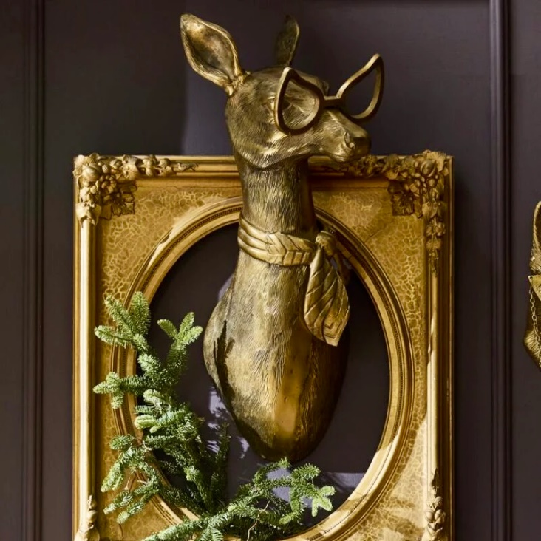The Margie the Doe wall mount is a charming and elegant decor piece that beautifully captures the gentle and serene essence of a doe. Designed with soft, feminine features and a sleek finish, it often incorporates modern or rustic elements, depending on the material and style. Crafted from resin, wood, or metal, this wall mount may feature neutral tones or subtle embellishments like floral accents, making it a perfect fit for cozy living spaces, bedrooms, or nurseries. Margie the Doe exudes warmth and tranquility, serving as a symbol of grace and nature.